EASTERN INTERNATIONAL UNIVERSITY **Practice Assignment – Quarter 4, 2024-2025**

**SCHOOL OF COMPUTING Course Name:** Advanced Java Programming

**AND INFORMATION TECHNOLOGY** **Course Code:** CSE 456

🙙🕮🙛 **Student’s Full Name:**

**Student ID:**

**LAB 02**

1. Familiar with Hibernate
   1. Write a Java application:
      1. Manage entities as follow

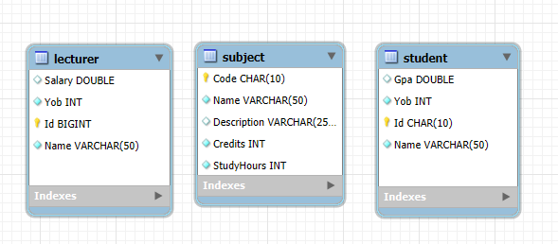

* + 1. The application should include
       1. Class definitions for each entity.
       2. Mapping Java classes to database tables by using Hibernate Core.
       3. Write methods to perform CRUD (Create, Read, Update, Delete) operations on the database.
       4. Suggest a name for the methods:
          1. insertStudent() – Adds a new student record to the database.
          2. getStudentById() – Retrieves a student's information using their unique ID.
          3. getAllStudent() – Fetches a list of all students from the database.
          4. updateStudentById() – Updates a specific student's details based on their ID.
          5. deleteStudentById() – Removes a student record from the database using their ID.
       5. Test all methods in main.